StarwarsApp by Guillermo Siliuto

Testing the Menu
- Start the aplication normally
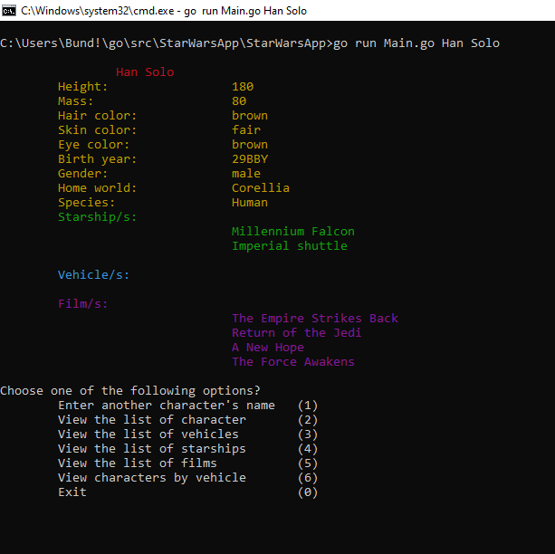
Shows the character information and the menu

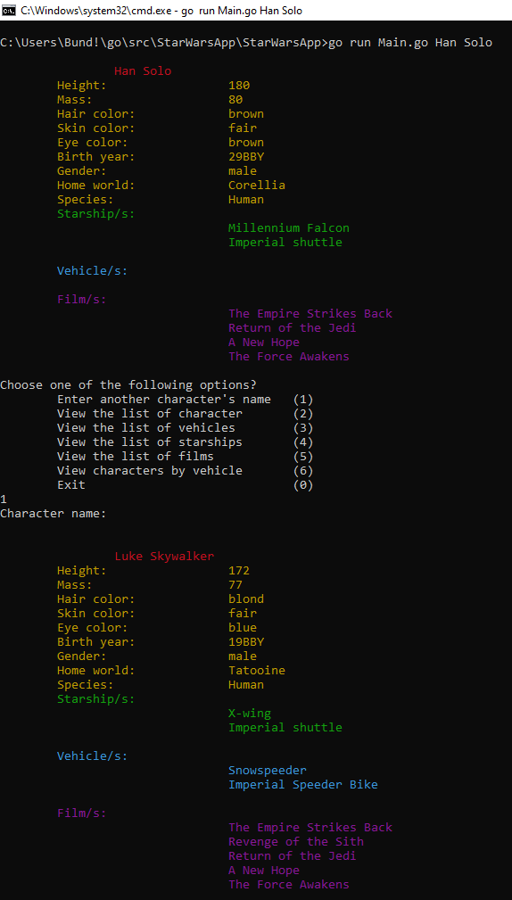
- Select first option and input no character name
Shows the first character from the database and shows the menu again
- Select first option and input a wrong character name
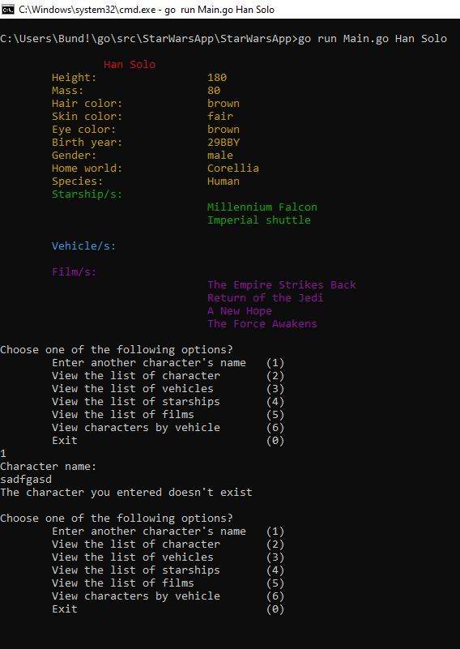
Shows an error and starts the menu again

- Select first option and input a correct character name
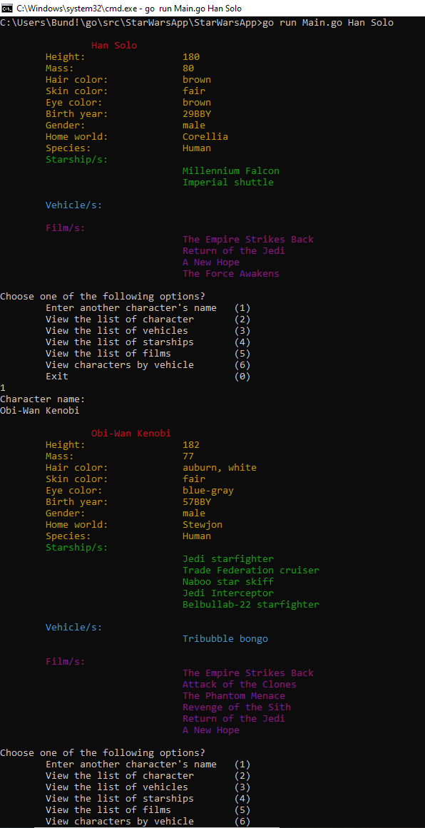
Shows the character information and shows the menu again
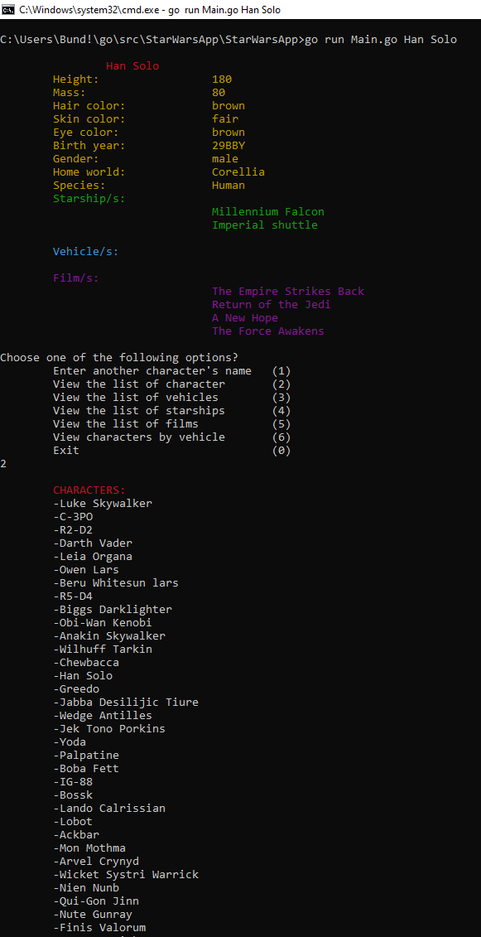
- Select the second option of the menu (view list of characters)
Shows the whole list of characters of the database and shows the menu again
- Choose the third option (view list of vehicles)
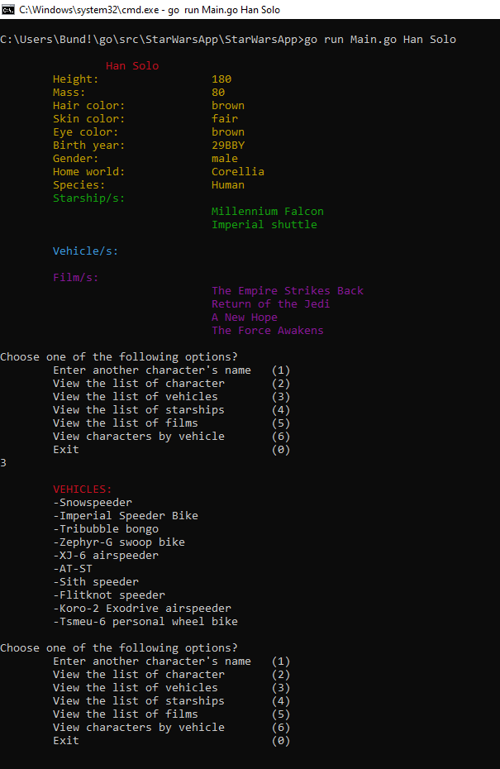
Shows the whole list of vehicles of the database and shows the menu again
- Choose the fourth option (view list of starships)
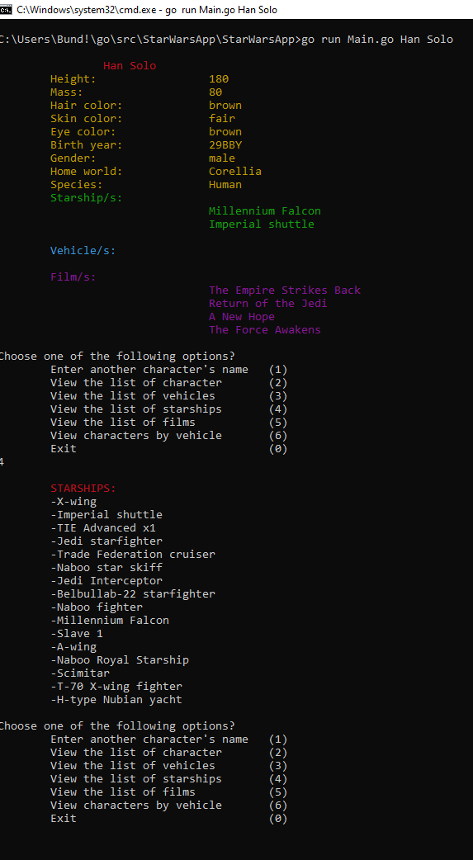
Shows the whole list of starships of the database and shows the menu again
- Choose the fifth option (view list of films)
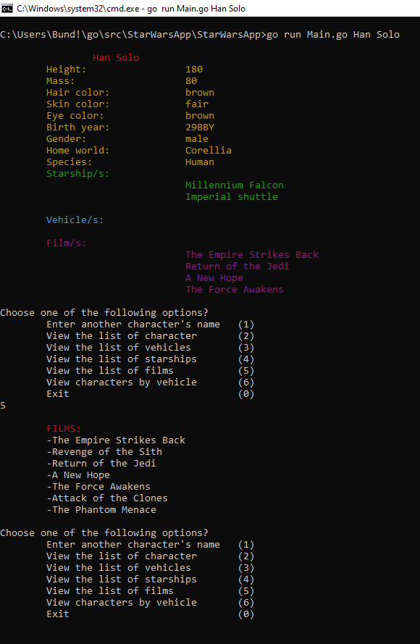
Shows the whole list of films of the database and shows the menu again

- Choose the "Exit" option
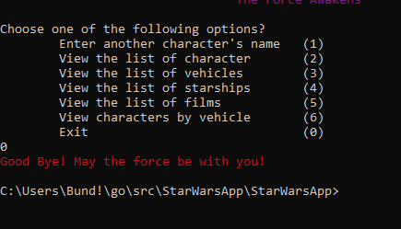
Prints a good bye message and closes the application

